Nama: Victory

NIM: 2602143353

Course: Data Visualization Final Exam

1. **Discrete fields** in tableau are typically used to represent categorical or distinct data points. Displayed as headers and used for data that can be counted or categorized. Discrete date fields inherently support hierarchies (Year, month, day, etc) allowing to drill down or roll up through different level of the data.

**Continuous fields** are used to represent data that fails along a continuous scale. It typically results in a continuous axis, such as number line and continuous field are ideal for numerical data that can be measured with precision. Displaying data seamlessly across the timeline.

In tableau Discrete fields shows as Blue color for dimensions and Continuous Fields show as Green Color for measure

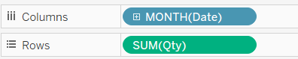

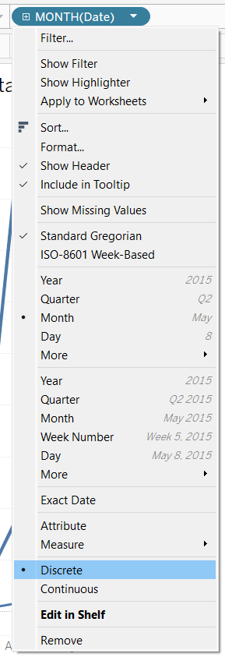



1. In tableau, conversion function is used for transforming data type to another type. These functions are useful when data type is not match with the specific calculations or visualizations. Purpose of conversion functions is data type consistency, Error prevention, enhanced analysis and improved flexibility. Common conversion function in tableau is DATE() to convert string to date, DATETIME() , STR() converts number into String, INT() and FLOAT()

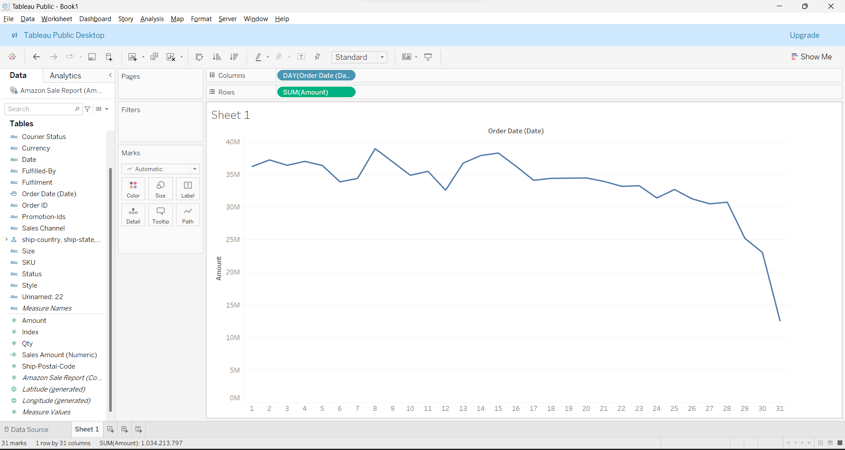

I change the date(String) to DATE() so I can filter It by day and also amount(Number Whole) to NUMERIC() decimal to measure it and SUM it.

1. **Histogram** display the distribution of a dataset by grouping data points into bins (or interval) and counting the number of data points in each bin and its useful for identifying patterns such as skewness or modality

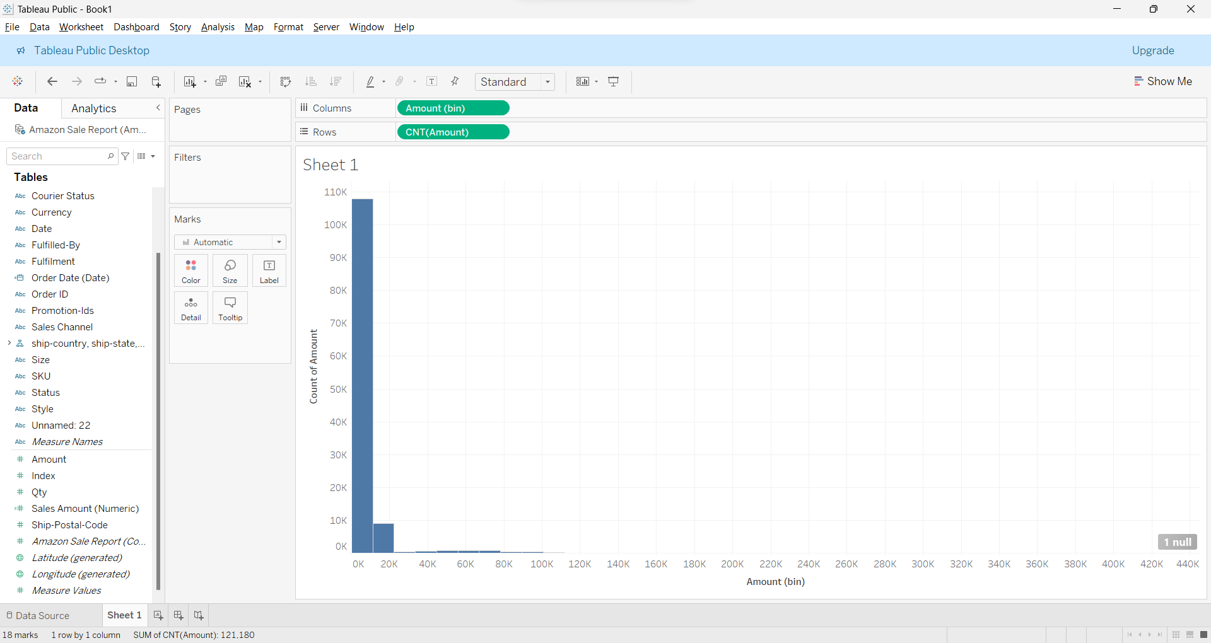

**Box & Whisker Plot** display the median, quartiles and outliers. Allowing for quick comparison of distribution and identifying the central tendency and variability

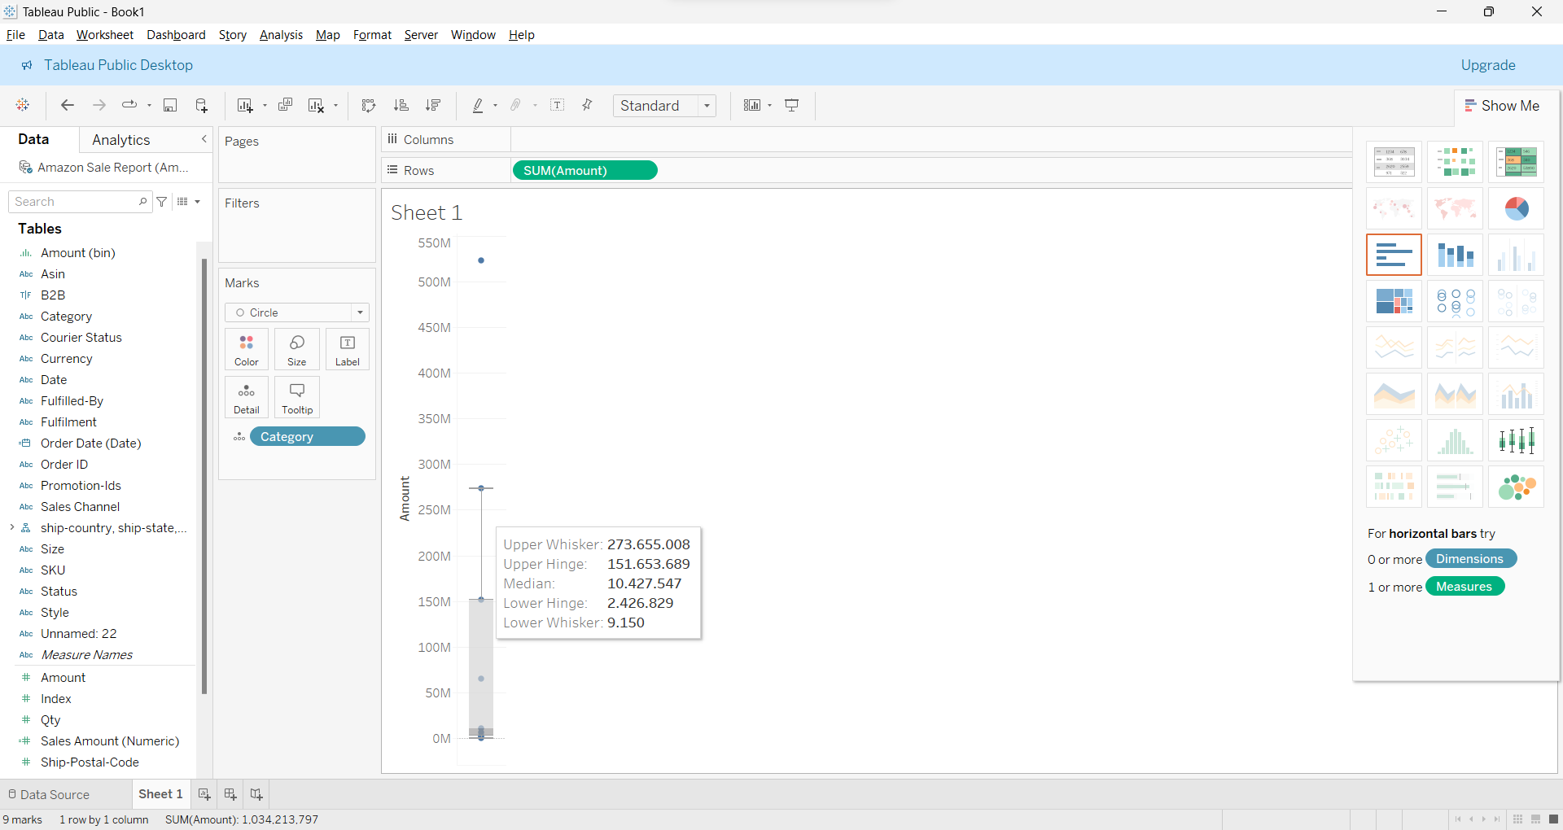

KASUS

1. Import the Amazon Sale Report dataset to Tableau.

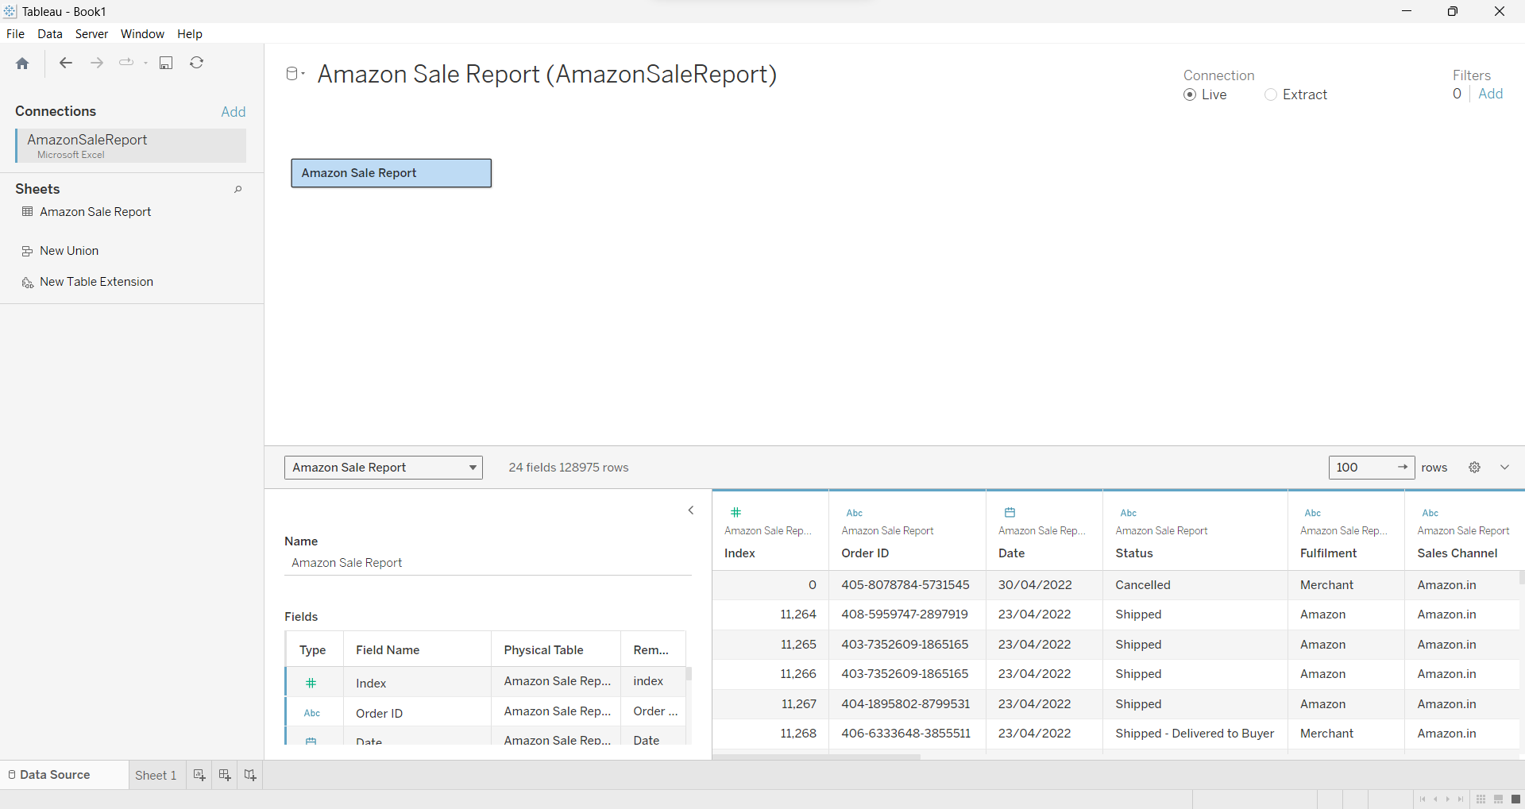

1. Only one data that wrong place which is **ship-portal-code** that in measure so i move it into Dimensions and some data type is incorrect so I changed it

* **Date** data type from String Changed into Date
* **Amount** data type from whole changed into Numeric Decimal
* **ship-portal-code** can be either number or String (I Use string because this field no needed for Aggregate or measure)

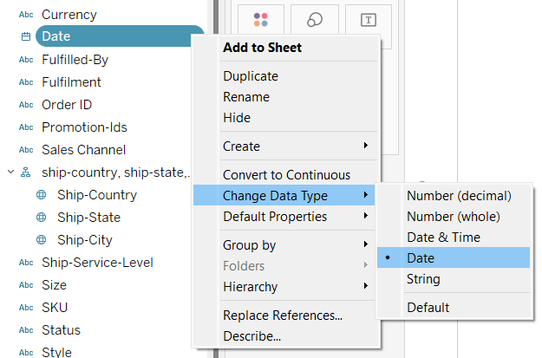

Another dimensions, measure and data type already correct.

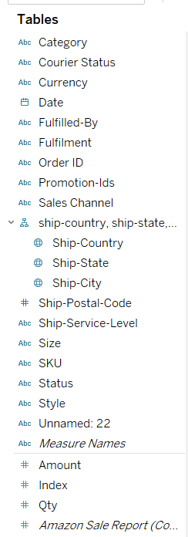

1. Save a dataset into a TDS file

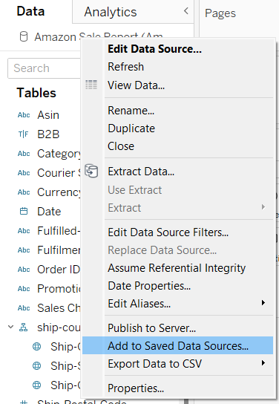

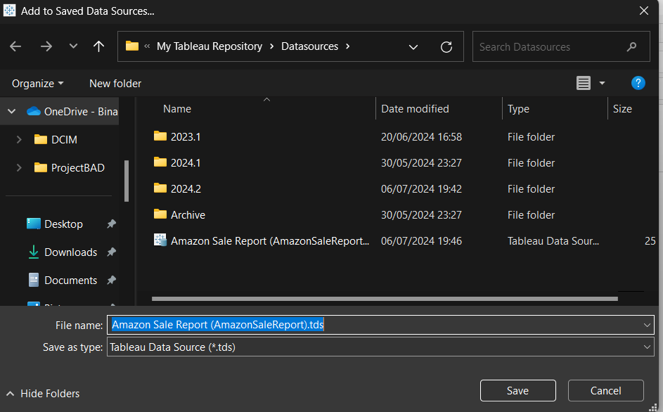



DONE! Already save into TDS FILE

1. Make a chart to show the trend of total quantity by Date (Month), Sales Channel, and Category. Add a filter to show the Top 5 only.

Drag date into column shelf and right click to change into Month to display by month

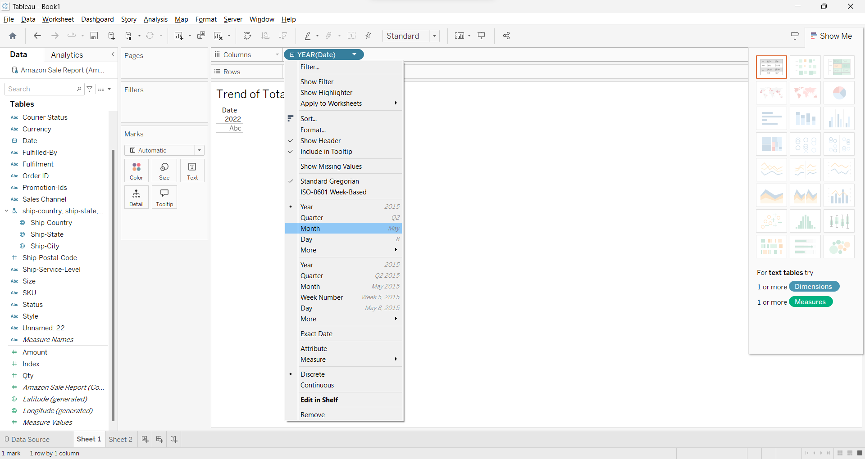

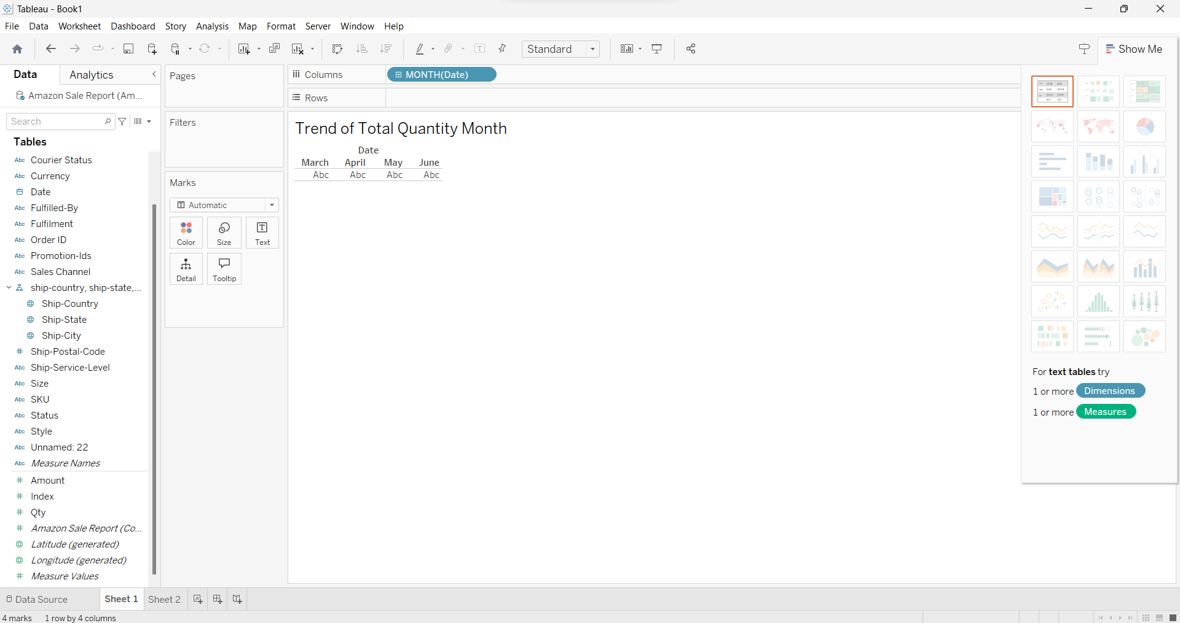

Drag quantity field into row shelf

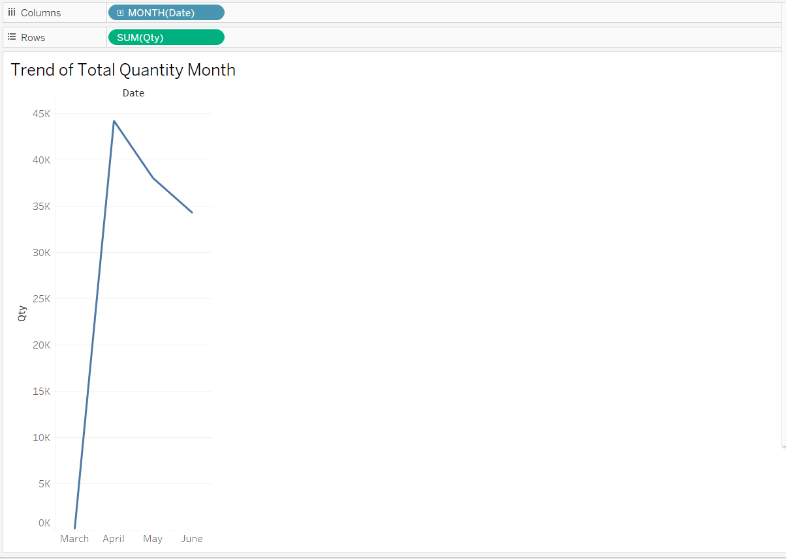

Drag Sales channel field into color shelf and drag category field into detail shelf on the marks cards

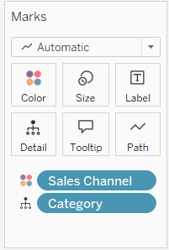

Drag category field also into filter shelf and then select TOP tab and by field and set into show the top 5 sum of quantity and then Click OK

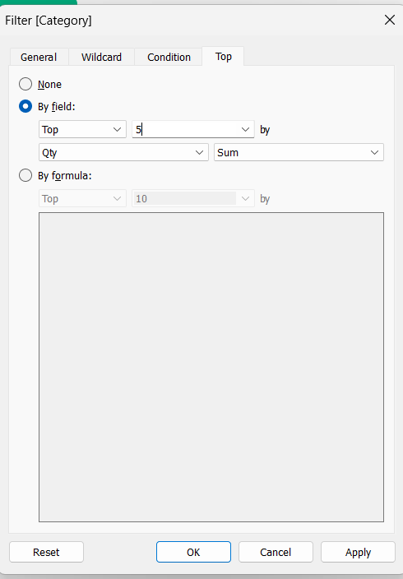

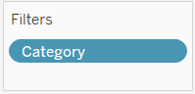

The Result:

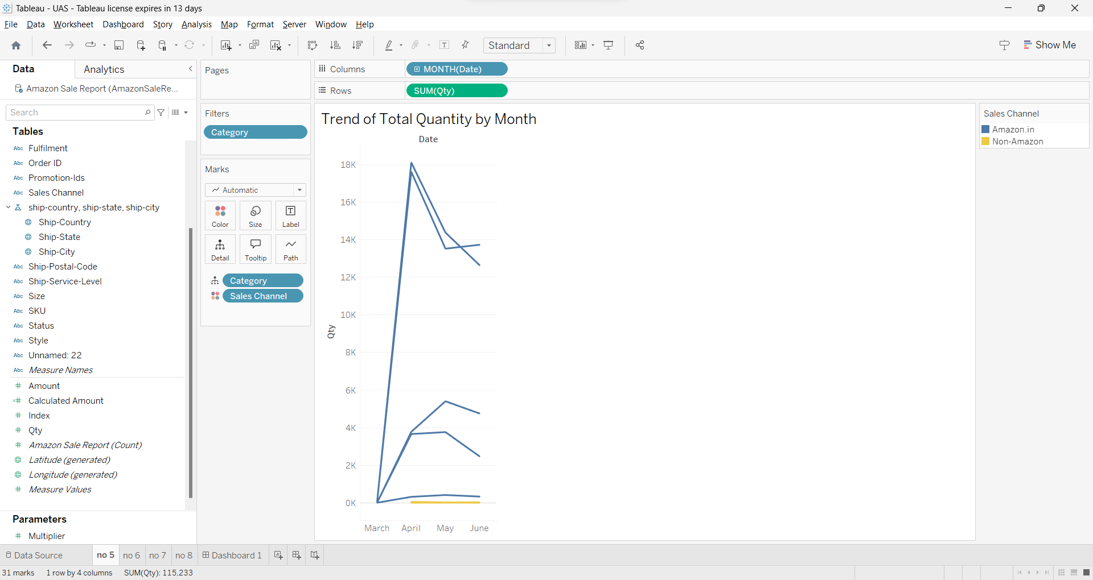

1. Make a text table to show the total quantity by Date (Quarter and Month), Ship-Service-Level, Fulfilment, and Category. Add subtotal and grand total.

Drag Date fields 2 twice to column shelf and right click on first date and change into Quarter to display in Quarter and then Select second date and change into Month to display in Month

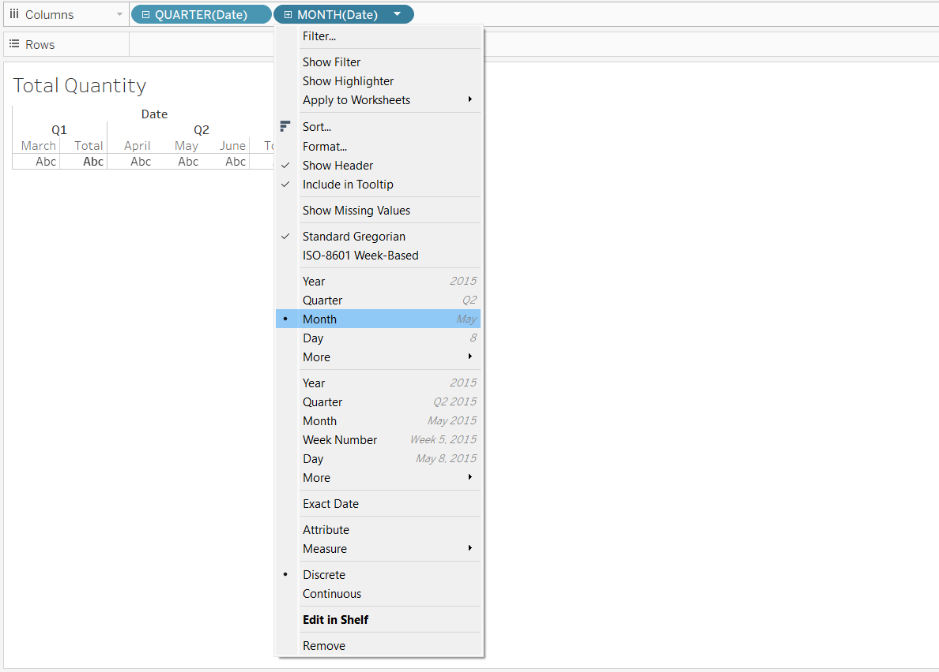



Drag ship-service-level, fulfilment and category to the rows Shelf



Drag quantity field to text shelf on the marks card

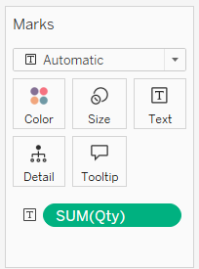

Add subtotal and grand total in analysist Tools by select totals and show row grand totals and show column grand total, also add all subtotals

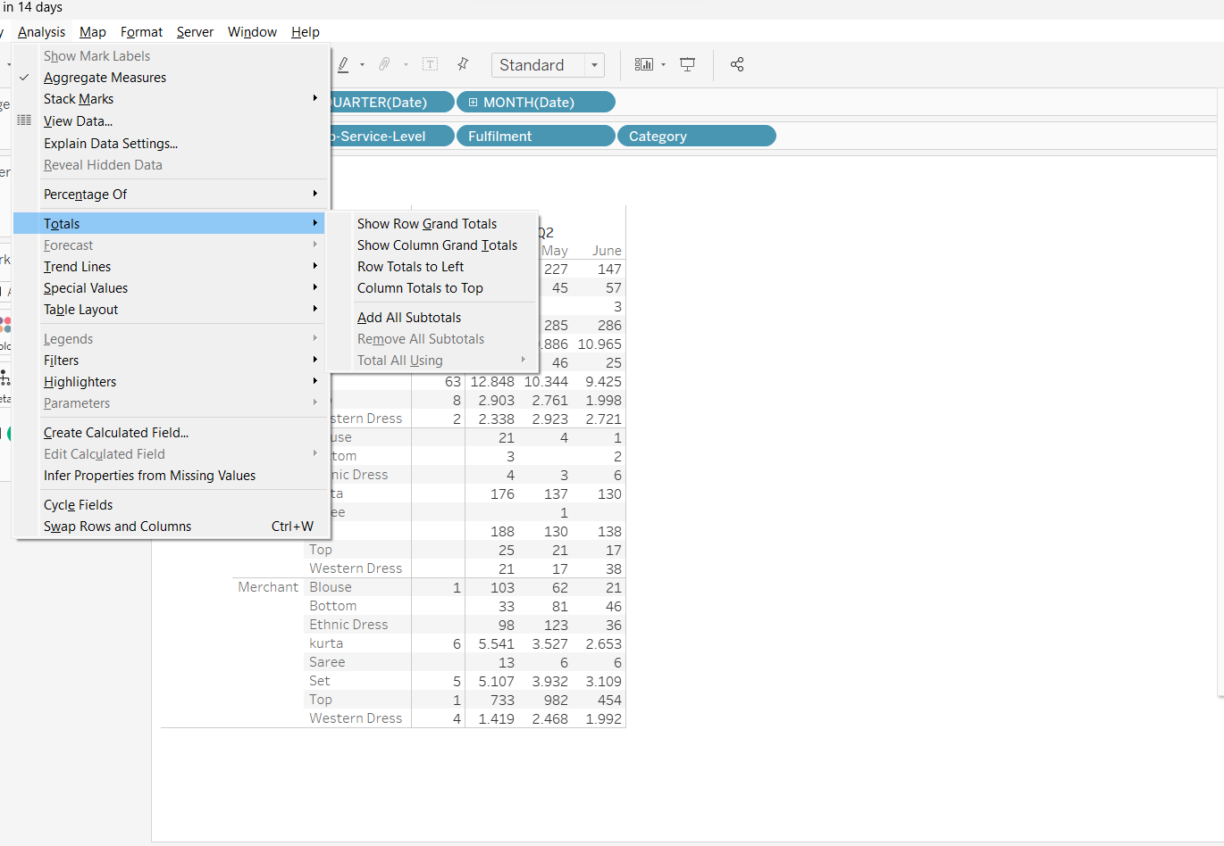



The Result:

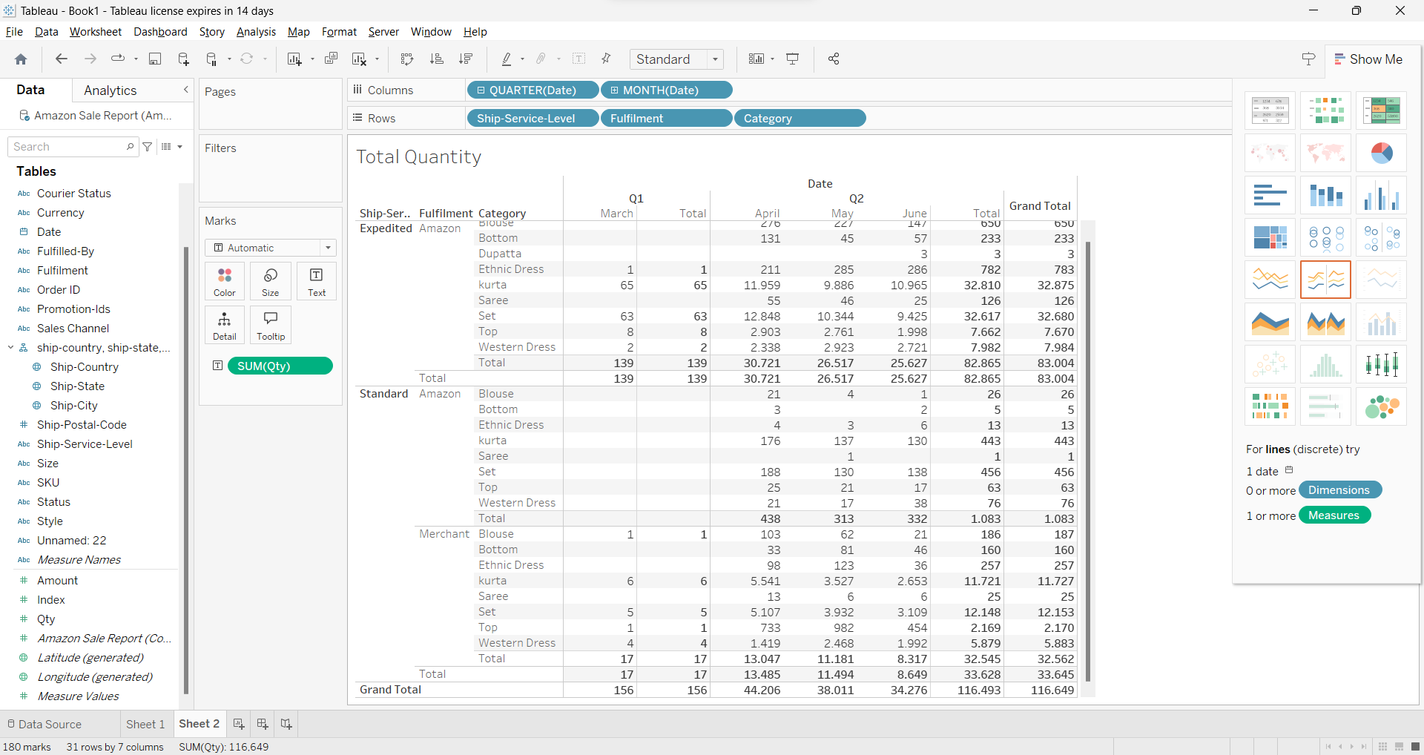

1. Make a chart to show the percentage proportion of distinct count of SKUs (using aggregate functions) by each Courier status.

Drag Courier Status to the column shelf

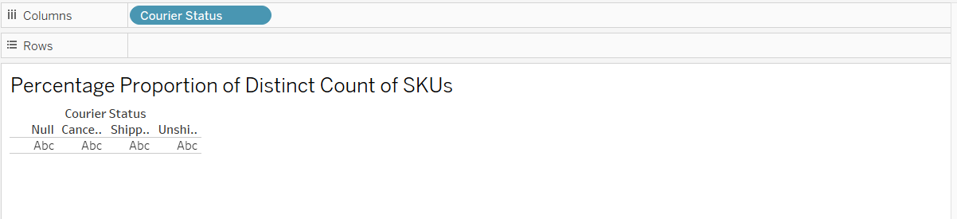

Drag SKU Field to rows shelf and right click on it and Measure > Count(Distinct)

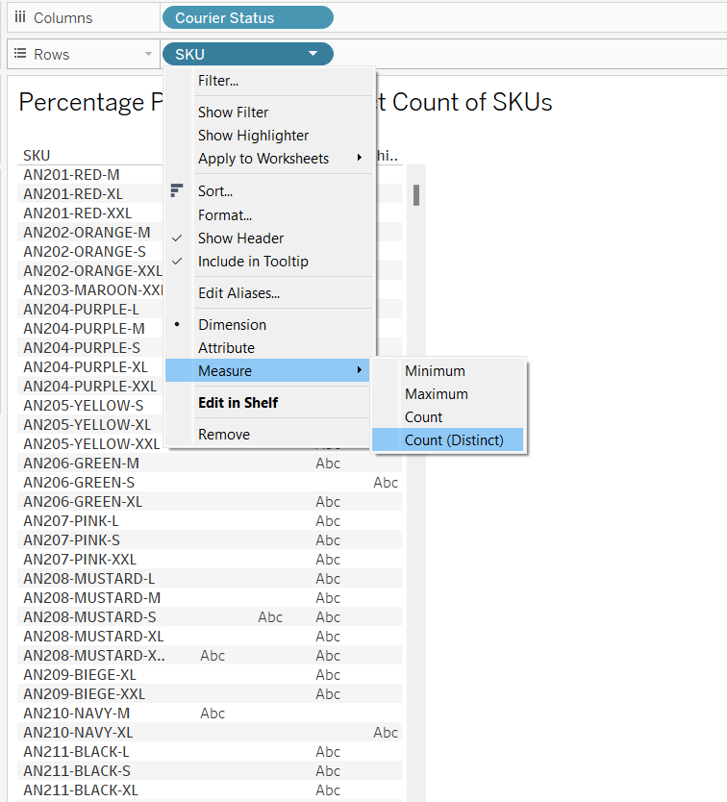

Right Click the SKU field in rows shelf and choose Quick Table Calculation and click on percent of Total

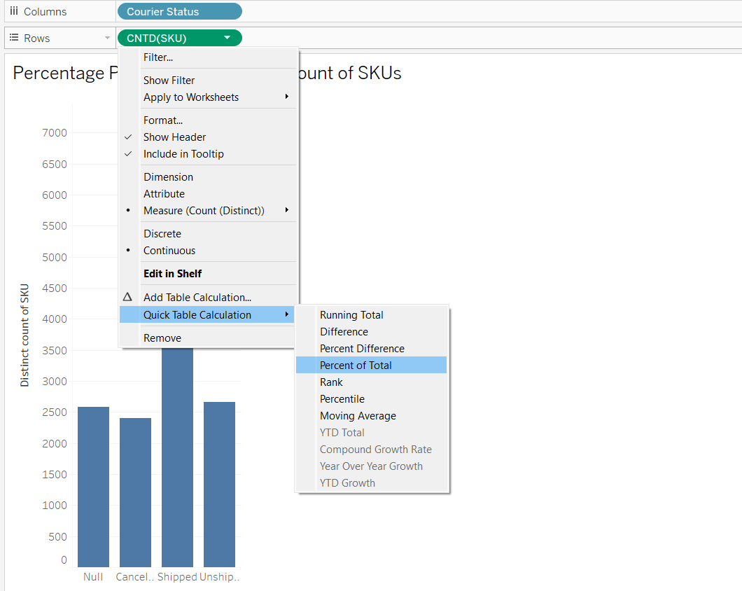

The Result:

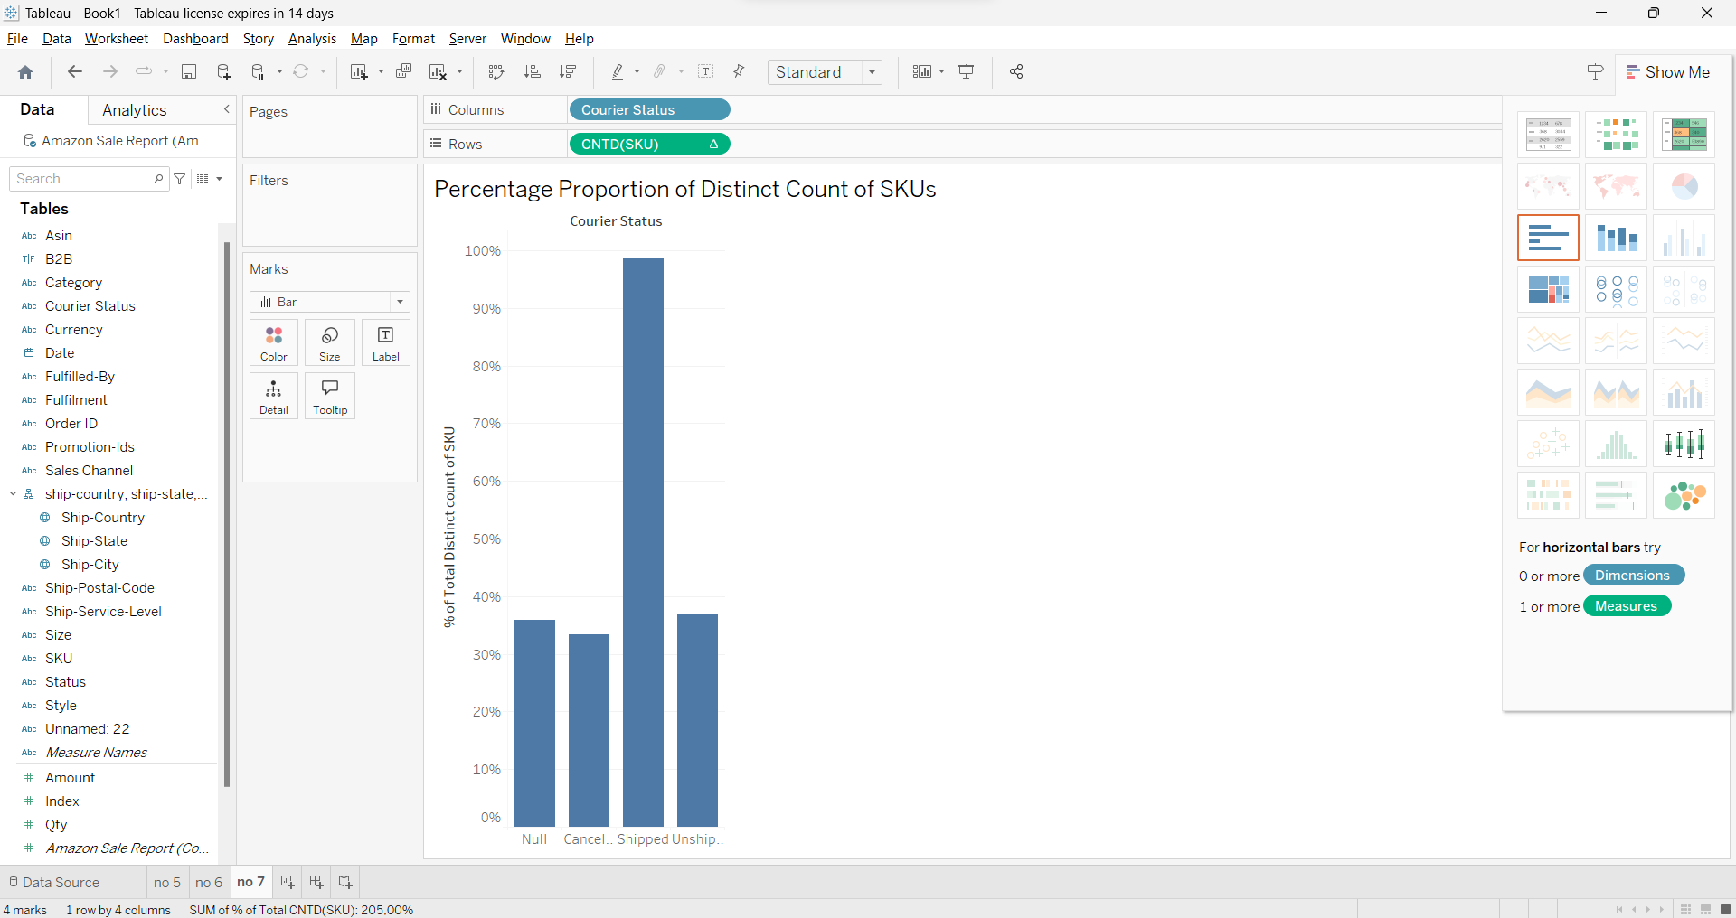

1. Make a chart to show the total amount by status. Create a parameter for the calculated field (total amount multiplied by parameter). Apply the parameter and show both the total amount and the calculated field in the chart

Drag Status field into Column shelf

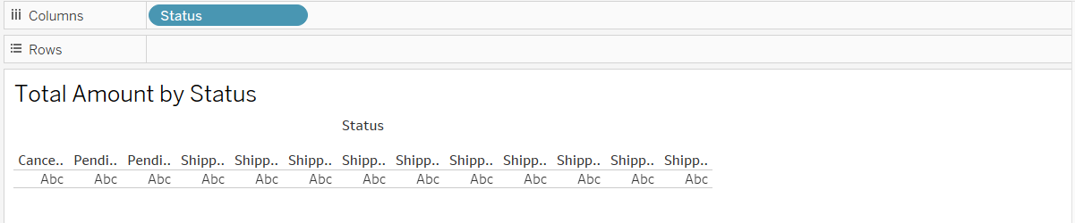

Drag Amount to Rows Shelf



Right click in datapane and select Create > Parameter

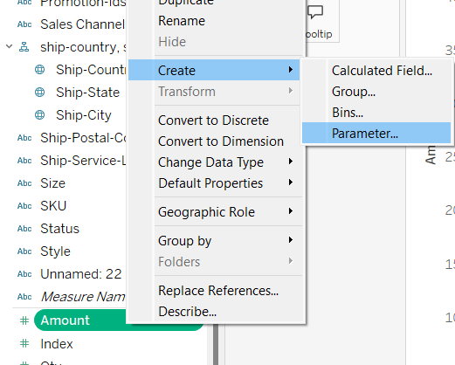

Name it “Multiplier” because we create the parameter for multiplier and then set data type to float and current value to 1

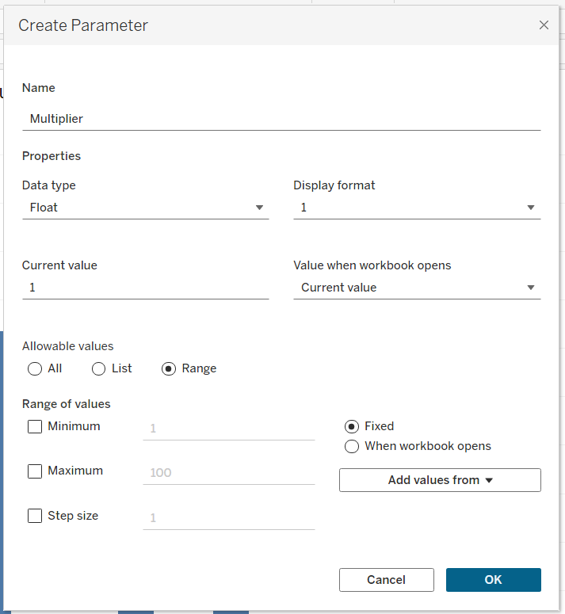



And Multiplier parameter created

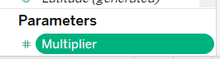

Right click on multiplier parameter and click show parameter

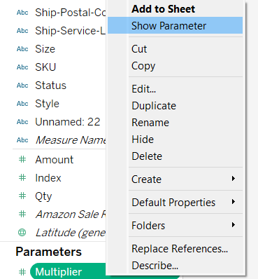

Right Click again on Data pane and click create > calculated Field

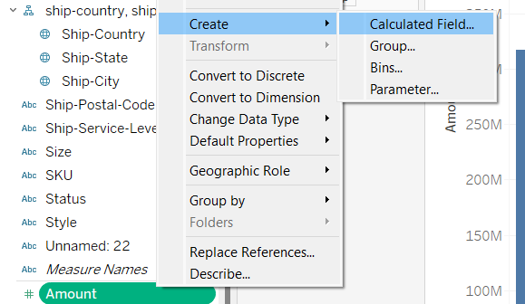

And input the formula [Amount] * [Multiplier]

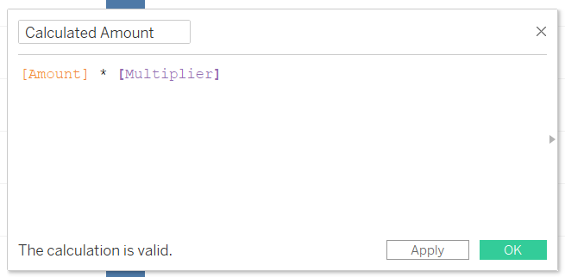

Drag Calculated Amount that created before to rows shelf

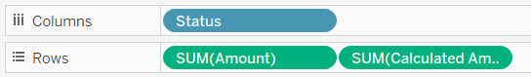



The Result:

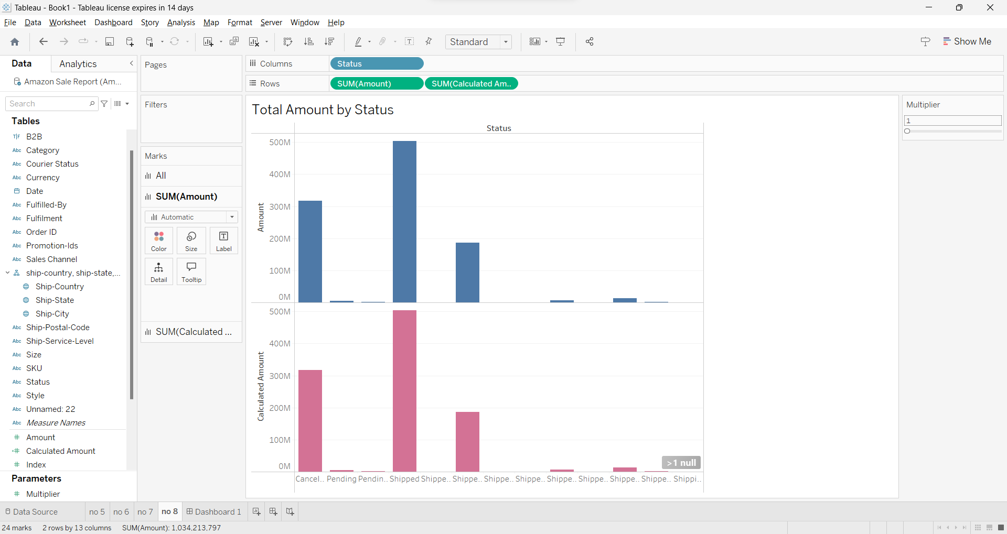

1. Design all your worksheets to a dashboard for a good data story and apply filter & highlight actions (minimum 1 of each action).

**Filter Actions 1**: When clicks on a Specific ‘Total Amount by Status’ Chart. The ‘Trend of Total Quantity by Month’, ‘Percentage Proportion of Distinct Count of SKUs’, ‘Total Quantity’ chart will update to show data only for the selected status. This allow for detailed analyst of each status

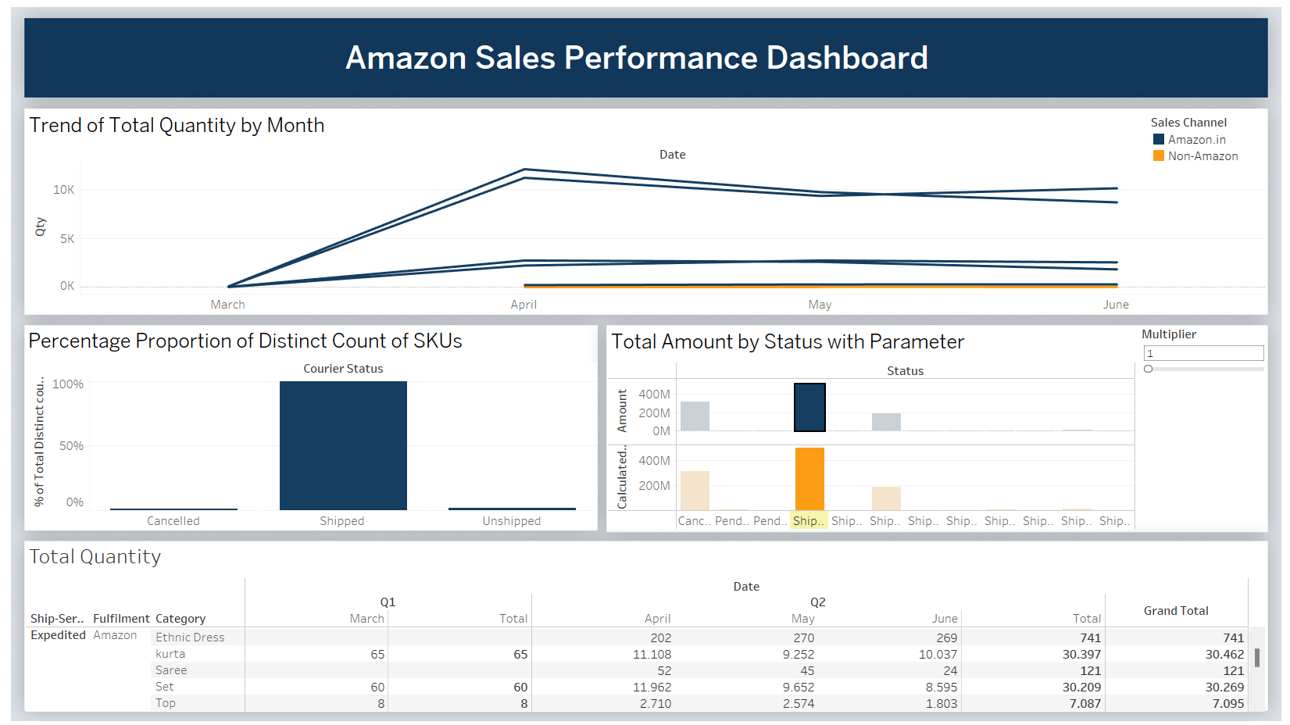

**Filter Actions 2:** When clicks on a Specific ‘Total Quantity’ Text table. The ‘Percentage Proportion of Distinct Count of SKUs’ and ‘Total Amount by Status’ chart will update to show data only for the selected status. This allow for detailed analyst of each Amount Sales of every month, category, ship service and fulfilment

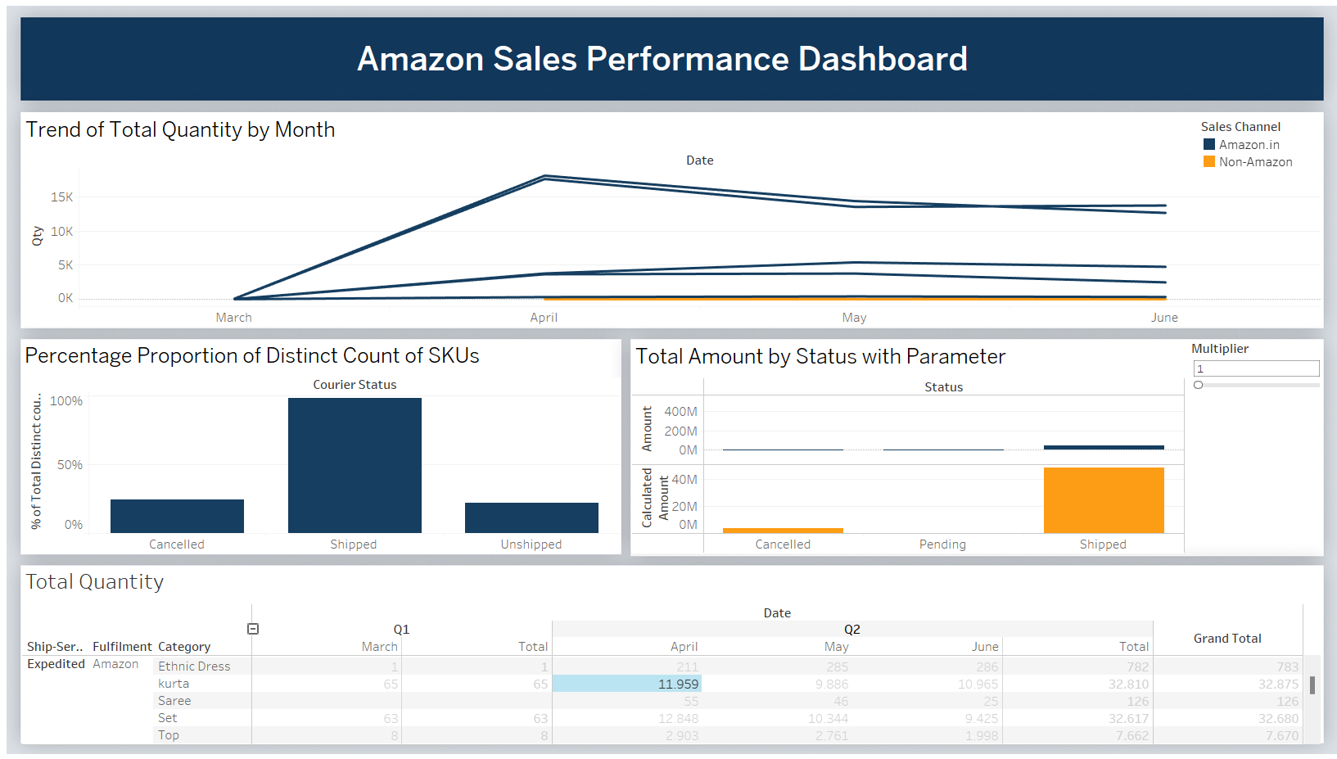



**Highlight Action**: When hover on Category in text table chart. Trend of Total Quantity by Month Chart will automatically highlight the trend Quantity in month for every category in line chart. Its help to analyst more detail about trend of top 5 category in every month.

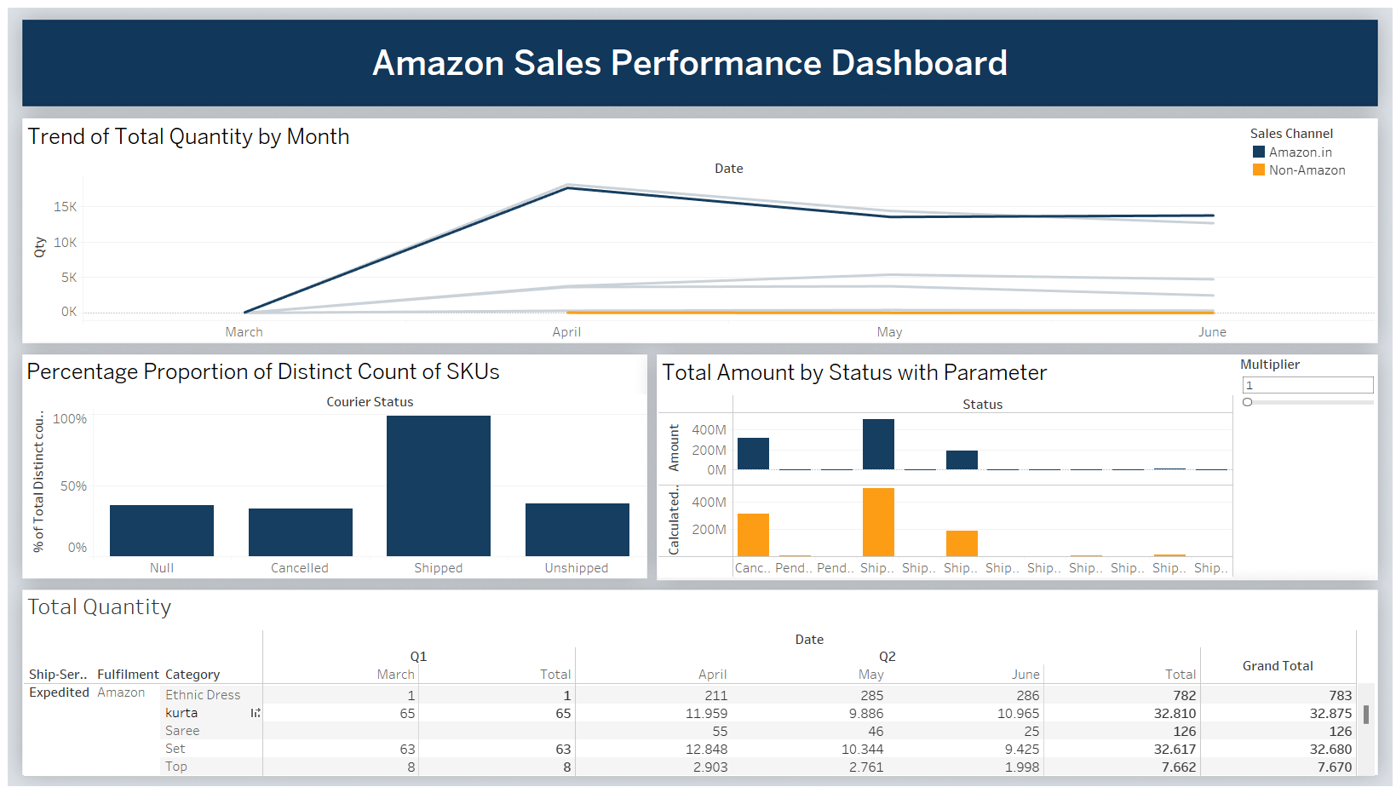

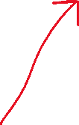

Dashboard overall Result:

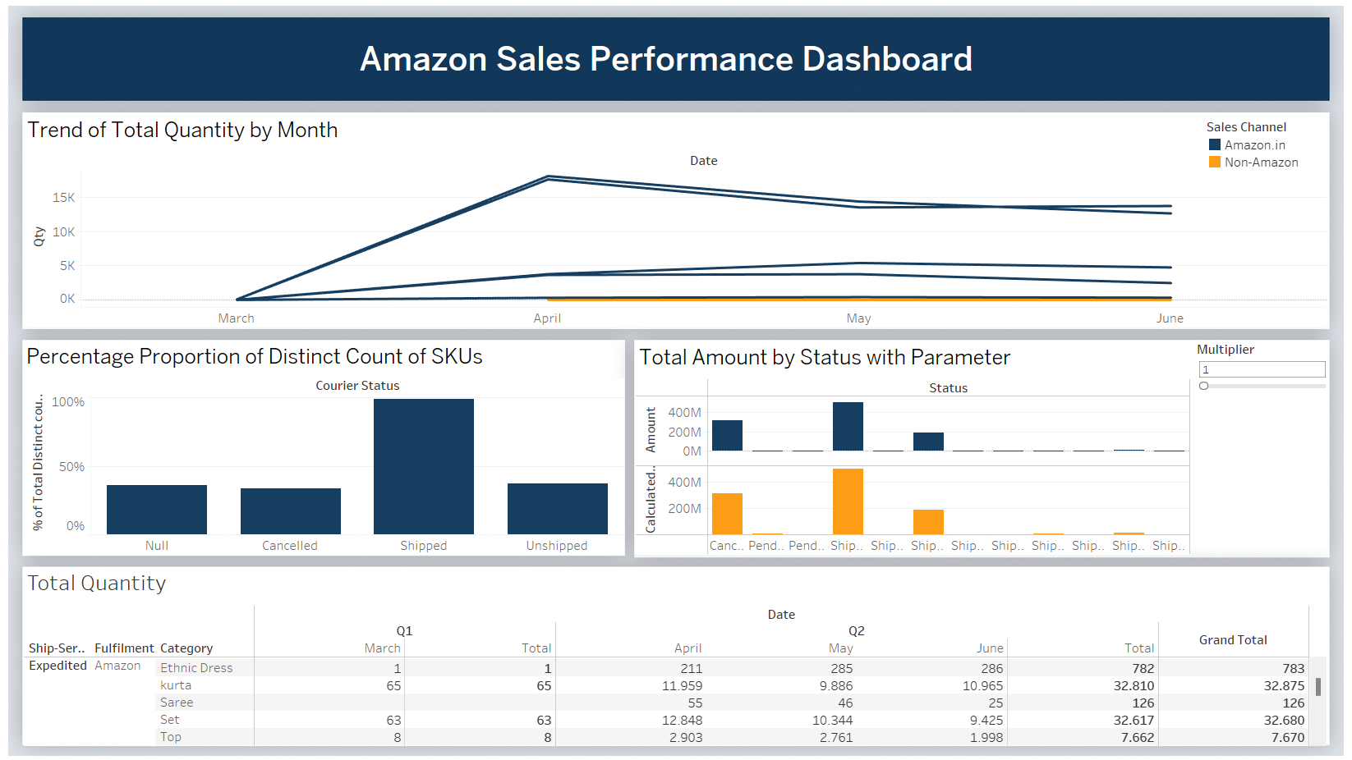

1. Create a video (maximum 3 minutes) of data storytelling based on the dashboard that you created for this case. The video must show your face and you must wear modest clothing. Upload the video to YouTube or similar tools and write the URL of the video on the answer sheet.

Youtube LINK: <https://youtu.be/LrrbnUvTiKU>

THANK YOU 😊